### **News Aggregation System (NAS) - Use Case Diagram**

#### 

#### **Actors:**

1. **User** (Primary Actor)
   * He can be a journalist, researcher, or general reader.
2. **Admin** (Secondary Actor)
   * Manages the system, including news sources, categorization, and user management.
3. **News API/RSS Feed** (External System)
   * Provides news data to the system.
4. **Web Scraping Tool** (External System)
   * Extracts news articles from various websites.

#### **Use Cases:**

1. **News Collection**
   * **Actor:** News API/RSS Feed, Web Scraping Tool
   * **Description:** The system collects news articles from multiple sources using APIs, RSS feeds, and web scraping techniques.
   * **Includes:**
     + Fetch News from API
     + Scrape News from Websites
     + Parse RSS Feeds
2. **Headline Categorization**
   * **Actor:** Admin
   * **Description:** The system categorizes news articles under common incident-based headlines.
   * **Includes:**
     + Group Articles by Incident
     + Assign Categories/Tags
3. **Source Verification**
   * **Actor:** Admin
   * **Description:** The system verifies the credibility of news sources.
   * **Includes:**
     + Check Source Reliability
     + Flag Unverified Sources
4. **Filtering**
   * **Actor:** User
   * **Description:** Users can filter news articles based on parameters like date, source, and category.
   * **Includes:**
     + Filter by Date
     + Filter by Source
     + Filter by Category
5. **Search for Specific Events**
   * **Actor:** User
   * **Description:** Users can search for news articles related to specific events or topics.
   * **Includes:**
     + Enter Search Query
     + Display Search Results
6. **Compare Media Perspectives**
   * **Actor:** User
   * **Description:** Users can compare different media perspectives on the same topic.
   * **Includes:**
     + Select Articles for Comparison
     + Display Side-by-Side Comparison
7. **Real-Time Updates**
   * **Actor:** User
   * **Description:** The system provides real-time updates on breaking news.
   * **Includes:**
     + Fetch Latest News
     + Notify User of Updates
8. **Sentiment Analysis**
   * **Actor:** User
   * **Description:** The system analyses the sentiment of news articles (positive, negative, neutral).
   * **Includes:**
     + Analyse Article Sentiment
     + Display Sentiment Summary
9. **Summary Generation**
   * **Actor:** User
   * **Description:** The system generates summaries of news articles to help users quickly grasp key insights.
   * **Includes:**
     + Generate Article Summary
     + Display Summary
10. **User Engagement**
    * **Actor:** User
    * **Description:** Users can engage with the system by saving articles, sharing them, or providing feedback.
    * **Includes:**
      + Save Article
      + Share Article
      + Provide Feedback
11. **Manage News Sources**
    * **Actor:** Admin
    * **Description:** The admin can add, update, or remove news sources from the system.
    * **Includes:**
      + Add News Source
      + Update News Source
      + Remove News Source
12. **User Management**
    * **Actor:** Admin
    * **Description:** The admin can manage user accounts, including creating, updating, and deleting users.
    * **Includes:**
      + Create User Account
      + Update User Account
      + Delete User Account

### **Relationships:**

* **User** interacts with:
  + Filtering
  + Search for Specific Events
  + Compare Media Perspectives
  + Real-Time Updates
  + Sentiment Analysis
  + Summary Generation
  + User Engagement
* **Admin** interacts with:
  + Headline Categorization
  + Source Verification
  + Manage News Sources
  + User Management
* **News API/RSS Feed** and **Web Scraping Tool** interact with:
  + News Collection

### 

### **Use Case Diagram for NAS:**

### 

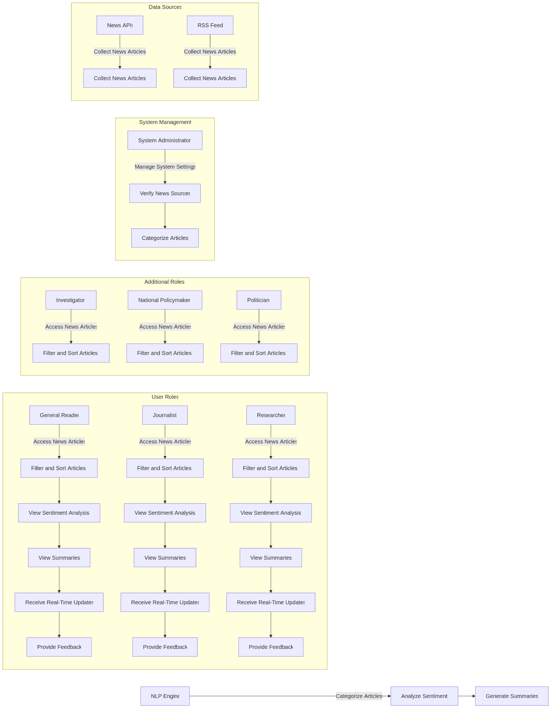

Using any UML tool, this textual representation can be converted into a visual Use Case Diagram. Let me know if you need further assistance!